Séquence AXE 1 : identités et échanges.

How has Britain’s perception of Europe shaped its History ?

Hello Brexit, goodbye Europe.

The Sun’s cover. June 14th, 2016.

Activity 1 = QCM on pronote to answer.
- The Sun is - British - American - Irish - Canadian
- The Sun is - gutter press - a broadsheet - a magazine
- The title of a newspaper is called - summary - headlines - subtitles
- This issue was published - after the exit of Britain from the EU - before the Brits voted in the referendum
- after the Brits voted in the referendum
- after the results of the referendum
e) The Sun - was against Brexit - was for Brexit - had no blunt opinion on Brexit
f) “BeLEAVE” is - a spelling mistake - a play on words - a motto
g) the colours used in the LEAVE word stand for - the Star Spangled Banner
- the Union Jack
- St George’s Cross
- St Andrew’s Cross

Back in the virtual class to recap and correct what they have done. Write a few sentences on the white board so that they can take notes on the important elements to remember.

CHECKPOINT = use the poll tool to send a few questions to make sure they have understood the vocabulary used.
- A pun is a play on words a summary a headline a motto
- Gutter press is a synonym for tabloids broadsheet papers magazines
- The referendum was organized in 2020 2010 2016 2021
- The British flag is called the Union Jack St George’s flag St Andrew’s flag
- Headlines is a synonym for summary a pun a referendum a title

Activity 2 = group work
On the CNED, launch the group App. You can launch it at random or decide of which students will be working together.
In groups, discuss whether these statements are TRUE or FALSE. You will have to justify your answer.

- Sir Winston Churchill was one of the first to call for a European cooperation and unity.
- The United Kingdom joined the European Economic Community in 1973.
- The 2016 referendum was the first to take place about Britain’s membership on Europe.
- The UK is part of the Schengen Area which allows every citizen to travel, work and live in any European country.
- The national currency in the UK is the pound.
- The withdrawal of the UK from the EU is called Brexit, a portmanteau of the words “Britain” and “exit”.
- The UK agreed to remain in the Erasmus Plus scheme.
- In 2013 Boris Johnson first campaigned to remain in the EU.
- Theresa May was the British Prime Minister who organized the referendum.
- The UK closed the book of close ties with Europe on January 31, 2020.

Back in the virtual class to recap and correct what they have done. Write a few sentences on the white board so that they can take notes on the important elements to remember.

Activity 3 :
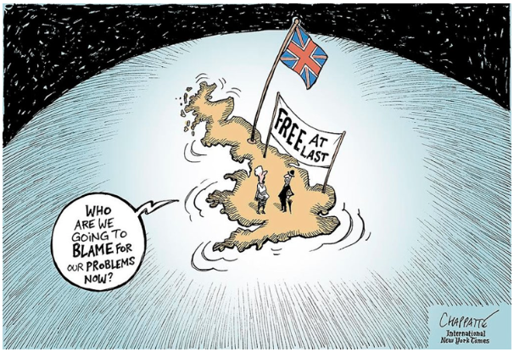
Patrick Chappatte, International New York Times, 2016

Description and analysis of the cartoon.
Use the whiteboard to jot down the main elements that have to be remembered.
It is possible to ask the students to write in the whiteboard to complete the grid.

the elements you can see (what is still there) | the missing elements (what you can’t see anymore)
the colours chosen | the cultural references
Transition : Is Britain really alone ? What is Britain counting on ?
Scan the QR code and do the activity.

CHECKPOINT = use the poll tool to send a few questions to make sure they are able to remember some countries.
- Find the odd one out Canada the USA Australia New Zealand
- Which of these countries is not in Africa ? Jamaica Uganda Cameroon Nigeria
- What is Cyprus in French ? Chypre Cisjordanie l’île Maurice Cyprien
- Which of these is not an island ? Guyana Australia Bahamas New Zealand

Activity 4 : watch the following video and let’s check what you’ve understood.
https://www.youtube.com/watch?v=69NzWP2kA_8

CO : Brexit: Big Ben bongs mark moment UK leaves European single market and customs union | ITV News

Write the link on the whiteboard and ask the students to watch the video and to write down keywords.

Keywords will be written on the whiteboard = allow students to write on the whiteboard the different words they have heard. Use the arrow to organize the different elements they are writing down in categories (people / dates / verbs / places …)

Then ask students to highlight or circle the main elements that have been written on the whiteboard.

Homework : write your summary in French for next time.

Activity 5 : let’s see what you remember and learnt.

Scan the QR code and do the activity.

